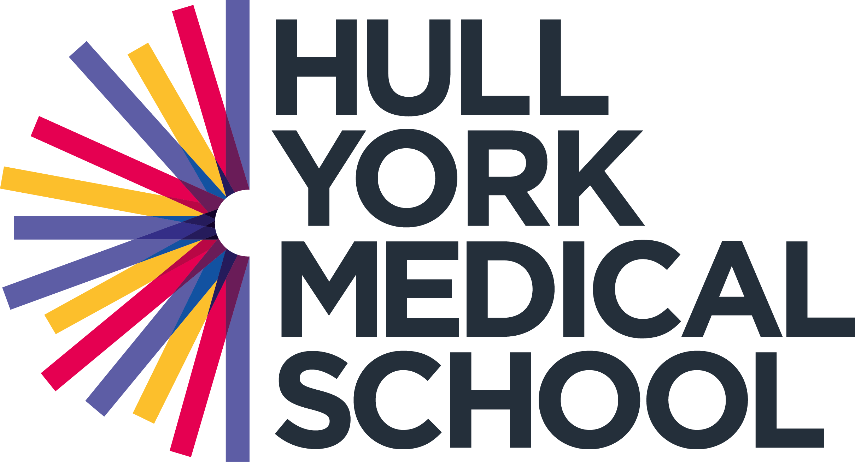

**NIHR Clinical Lecturer in Respiratory Medicine**

Hull York Medical School, University of York and NHS England North East and Yorkshire

|  |  |
| --- | --- |
| **Post:** | **NIHR Clinical Lecturer in Respiratory Medicine – based at the University of Hull** |
| **Reporting to:** | **Professor Alyn Morice, Respiratory Research Group, Hull York Medical School** |

**Interview date – TBC**

**Job Description**

**The Post**

The NIHR Clinical Lectureship (CL) is a post-doctoral award that provides a clinical and academic training environment for doctors and dentists to establish themselves as independent researchers and leaders.

This award has a standard duration of 4 years or until completion of clinical training (CCT/CCST) is reached, whichever is sooner. Alternatively, you can undertake the award part-time and for a maximum duration of 6 years, as long as the academic component does not fall below 33% of whole time equivalent.

As a CL you will spend:

* 50% of your time in specialist clinical training
* 50% in research or educationalist training.

To be eligible for a CL you must:

* Be in higher speciality training (Respiratory)
* Have completed a research doctorate (PhD) or equivalent
* Show outstanding potential for continuing a career in academic medicine.

**Research**

We are seeking a highly motivated, enthusiastic individual wishing to excel in both their clinical and academic training, with the ambition to join the next generation of world-leading academic clinicians.The successful candidate will have a proven track record in initiating and undertaking original research, evidenced by a strong publication record. Successful exit from the academic training programme will leave you well-placed to seek competitive research fellowships and academic senior lectureships.

**Clinical Training**

The successful applicant will work with the Training Programme Director and Academic Lead to develop a configuration of research to clinical training conducive to both progression and academic output. Clinical training will be within East Yorkshire, within the wider NHS England North East and Yorkshire region.

**Teaching**

The appointee will be involved in teaching HYMS medical students and may have the opportunity to co-supervise BMedSci, MSc, MD and PhD students.

**Supervision**

The Lecturer will be appointed with a clinical and academic educational supervisor. The Annual Review of Competence Progression (ARCP) which will be conducted by NHS England North East and Yorkshire.

**Bursary and support**

The NIHR training bursary provides trainees with a source of funding to attend meetings and conferences that are relevant to academic training.

The NIHR bursary provides up to £1,000 per financial year per trainee to the host medical school. The medical school is responsible for managing the bursary fund and your medical school is therefore responsible for approving expenditure against the bursaries. Unclaimed bursary funds currently remain with the medical school for use on activities that benefit the academic development or training of the NIHR CL trainees.

**Commencement date and duration of appointment**

The candidate must be available to take up employment by 31st August 2026 at the latest. The duration of the post is up to 4 years fixed term or until CCT/CCST is reached, whichever is sooner. Alternatively, the post can be up to six years less-than-full-time; the academic component should comprise at least 33% whole time equivalent.

**NIHR Guidance**

All applicants who do not already hold a National Training Number (NTN) or Deanery Reference Number (DRN) in the GMC specialty to which they are applying for will be required to undertake the national clinical recruitment process and attend an assessment/interview for that GMC specialty as appropriate.

Doctors appointed as an NIHR CL **must already hold a higher research degree** (PhD, MD, or equivalent) and either hold MRCGP and have completed their clinical training, or be a specialist /speciality registrar. Candidates may only apply if they have already submitted their PhD or MD thesis at the time of application

[NIHR eligibility guidance](https://www.nihr.ac.uk/documents/nihr-clinical-lectureships-medical-guidance-for-recruitment-and-appointment-2023/32783#eligibility)

Informal enquiries may be addressed to Professor Alyn Morice, [A.H.Morice@hull.ac.uk](mailto:A.H.Morice@hull.ac.uk) or Professor Michal Crooks, Hull York Medical School, [michael.crooks@nhs.net](mailto:michael.crooks@nhs.net)

Further information and details of how to apply can be found at:

https://www.hyms.ac.uk/work-with-us/nihr-academic-training-programme-opportunities

**The Hull York Medical School is an equal partnership between the universities of Hull and York.  It operates in association with the NHS in North and East Yorkshire and Northern Lincolnshire.  For further information about HYMS, visit** [www.hyms.ac.uk](http://www.hyms.ac.uk)**.**

**Person Specification**

Please refer to the NHS England North East and Yorkshire website for details specific to this specialty:

<https://specialtytraining.hee.nhs.uk/Recruitment/Person-specifications/2015-person-specifications>

|  |  |  |  |
| --- | --- | --- | --- |
| **Specification** | **Essential** | **Desirable** | **Examples Measured by** |
| Eligibility | * Evidence of achievement of Foundation competences or equivalent. * Evidence of good progress in clinical training and that completion of specialty training may be accommodated either during or soon after the of the NIHR CL award. * Candidate **must be at ST4 or above and hold a current National Training Number (NTN) or be clinically benchmarked.** | * Intercalated honours degree and/or additional qualifications e.g. MSc etc. * Evidence of commitment to GMC specialty. | Application |
| Education and Training | * **Must hold a higher degree** (MD, PhD or equivalent) in a **relevant** discipline (**Note**: higher degree must be submitted by application and awarded by start date). * Demonstration of understanding, and commitment to, an academic career. * Demonstration of educational reasons for applying for Clinical Lectureship Programme. | * Working towards, or completion of, a teaching qualification. | Application |
| Work Experience | **Evidence of:**   * An emerging track record in health research, including scientific publications, presentations at scientific conferences and contributing to grant applications. * Presentation of work at national or international meetings. * Publications in peer reviewed journals. * Demonstration of the potential for scientific independence and ability to lead a research team. | * Experience of working in multidisciplinary research teams. * Evidence of research income. | Application  Interview |
| Skills and Knowledge | **Evidence of:**   * Demonstration of the potential for scientific independence (which may include developing innovative and robust proposals, attracting research funding, publication in peer reviewed journals). * Effective team work and collaboration. | * Prizes or distinctions. * Experience of dissemination of research. * Contribution to the supervision of research students. * Effective management of resources. | Application  Interview |
| Personal Qualities | * Potential to become a leader in chosen field. * An expectation to positively contribute to University activities and initiatives. * Collaborative working * Effective communicator. * Team working skills. |  | Application  Interview |

**Appendix 1: Further particulars – Hull York Medical School**

**Hull York Medical School**

Hull York Medical School is committed to transforming the health of people within the region and beyond – through its students, staff and the impact of its teaching and research.

The joint medical school of the Universities of Hull and York, Hull York Medical School has a reputation as one of the UKs most exciting, contemporary schools. The School was established in 2003 – combining York’s strength in biological sciences and health sciences and Hull’s expertise in clinically applied health research and large clinical base. Since then, has been inspiring doctors and academic leaders of the future with the research, skills and knowledge they need to look at things differently and advance improvements in healthcare around the world.

Equality, diversity and inclusion are extremely important to the School, and in line with its values of everyone counts, pursuing excellence, socially responsible and collaborative, it is committed to providing an inclusive and supportive environment for staff and students. The School was awarded the Athena Swann Silver Award in 2019, has signed up to the UK Medical School’s Charter on So-Called ‘Conversion Therapy’ and the British Medical Association (BMA) racial harassment charter.

**Inspiring doctors and academic leaders of the future**  
Hull York Medical School offers exceptional medical education delivered by senior academics and clinicians in a stimulating and supportive environment with world-class facilities.

At undergraduate level the School’s MB BS Medicine programme offers an innovative curriculum focused on clinician led problem-based learning and early and sustained clinical exposure across a range of primary and secondary healthcare settings. This approach ensures students graduate as excellent thinkers, evidence-based practitioners and patient-centred communicators who are able to deliver brilliant healthcare.

The School’s postgraduate taught programmes offer students the opportunity to deepen their understanding of subjects such as clinical anatomy and pharmacology and drug development and their applications in practise and education. Courses are also available for health professionals interested in education and educational research. In addition, the School offers a Masters in Physician Associate Studies.

Postgraduate research students benefit from a thriving research community and the opportunity to learn from world leading experts who are internationally recognised for their work.

Hull York Medical School facilities at Hull and York offer a stimulating environment in which to learn. The Allam Medical Building at the heart of the University of Hull’s £28million Health Campus is home to Hull York Medical School in Hull. Opened in 2017 by Her Majesty the Queen, the Allam Medical Building provides specialised teaching facilities including a simulated ward, operating theatre and intensive care nursing facilities, and provides opportunities for medical students to work alongside, nursing, midwifery and allied health undergraduates, as well as PhD students, advanced nurse practitioners and physician’s associates.

At York, Hull York Medical School students have a dedicated facility on the University’s west campus which has recently undergone a £5.8 million investment. The building is centred on 500 acres of landscaped campus and the University has, since 2000, invested an unprecedented £500million in facilities including accommodation, research facilities and a sports campus.

Students across both campuses also benefit from state-of-the art anatomy facilities.

**A partnership for people who want to make a difference**  
Academic and clinical researchers at Hull York Medical School have a strong reputation for their work. Their research is advancing improvements in healthcare – treatment, diagnosis and care – for some of the major global health challenges of today.

At Hull, the School’s researchers are at the forefront of health research, from the early diagnosis of cancer, to reducing inequalities in access to treatment and improving the lives of those with life-limiting illnesses. This work is improving the health of people locally and impacting national and international health agendas.

At York, the School’s researchers have a global reputation for their work. From scientific discoveries that underpin the development, diagnosis and treatment of the world’s most aggressive diseases, to mental health research which addresses the needs of a wider variety of patients and helps to identify, treat and support them, this work is casting new light and impacting public health globally.

**Partnerships**  
As well as a unique partnership between the Universities of Hull and York, Hull York Medical School works with NHS Trusts, Mental and Community Health organisations and GPs across the Yorkshire region. These partnerships ensure the School remains in touch with the healthcare needs of the communities it serves as well as abreast of current and future workforce challenges and enable the School to deliver exceptional medical education to its MB BS Medicine and Physician Associate students.